Place postage stamp here

James D. Rader – Chapter 108
P.O. Box 152257
Cape Coral, FL 33915

--------------------------------------------------------------------------------------------------------------------------------------------

November 2020 CHAPTER NEWSLETTER
www.davcapecoral.org

Help us in our fund-raising efforts with your donation!
BUILDING BETTER LIVES FOR AMERICA’S DISABLED VETERANS
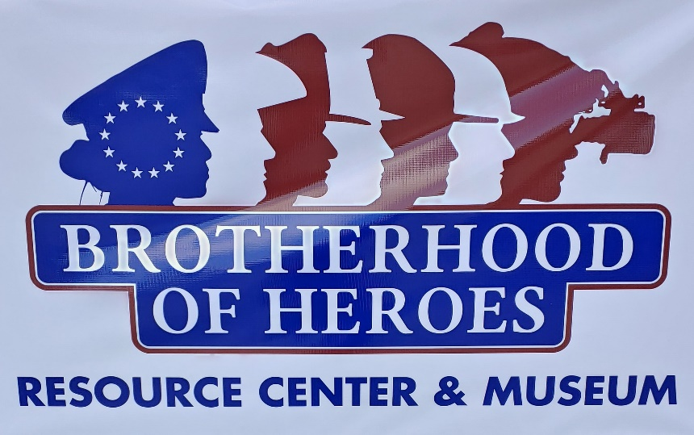

Chapter meetings are held the 2nd Thursday of each month at the Brotherhood of Heroes Building, 4522 Del Prado Blvd South
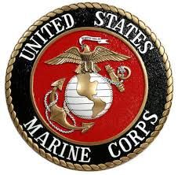

Commander’s Corner

Dear Comrades:

Well, we now have 2 offices to fill. They will both be up and running just before our next general meeting on 12 NOV.

We will not be having a Christmas party due to lack of space, time and Covid Virus safety measures. We will still try to assist veterans for Thanksgiving and Christmas though.

Our first office in Cape Coral will be available M-F 1000-1400 hrs. We don't have phones yet hooked up but are working on it. The second office will run M-Th 1000-1400 hrs. We will have computers in each office. Phones are forthcoming. Manpower is another story.

We welcome anyone in the Chapter that wishes to help out. You don't have to be a certified Chapter Service Officer (CSO), to participate. We appreciate any help we get.

Our E-board meeting is 1100 hrs on 5 NOV 2020, Cape Coral office, 4522 Del Prado Blvd South. I expect all elected officers to be there. Please notify me if you can't make it.

Our general meeting is 1300 hrs 12 NOV 2020. We are still assisting veterans even without our offices. If you know a fellow veteran that needs help, let us know either at the next meeting or by phone beforehand.

Until then,
be safe and God Bless!

Steven A Berger
Commander, DAV Chapter 108

Additional information related to the relocation of the chapter office:
The Military Museum on Leonard Street has been officially closed since October 1, 2020.
The Gunterberg Charitable Foundation – Culliton Family has graciously provided our chapter with an office space in the newly named Brotherhood of Heroes Building. The building is located at 4522 Del Prado Blvd South, which formerly housed the Budget Floors Company.
Our general chapter meetings will be held at the new location. We will also have a lunch provided at 12 pm by Mission BBQ. We will need volunteers to serve the meal and assist in cleaning up. There are only 12 parking spaces in front of the building which we would have to share with the Brotherhood of Heroes Organization and a branch of the Lee County Sheriff’s Office. Chapter members are requested to park at the side or the rear of the building where there is ample space.
Pete Schwarz
Commander | Adjutant | Treasurer/Editor
Steve Berger | Ed Hawkins | Pete Schwarz
470-865-8474  239-470-1950  vnmanchu@msn.com | 423-319-6656 | 239-540-5918
stevenberger5383@yahoo.com | hit_man911@hotmail.com | peter1pat2@gmail.com

- We have an office inside the Brotherhood of Heroes Building
- Follow us on Facebook (DAV#108CapeCoral)
- Email us at dav108capecoral@yahoo.com

Chaplain’s Corner:
Sickness and Distress - Comrades in need of our support and prayers:

  - Larry D’Angelo
  - Peter Palkowski
  - Richard Margey
  - Ed Hawkins

If you are aware of a comrade in need, please notify Commander Steve Berger or Chaplain Juan Cordero (239-989-9310. And remember, the very nature of our organization dictates that all our members have ailments and deserve our prayers.

Upcoming Meetings and Events!
November 5: Executive Board Meeting at 11 am
November 12: General Chapter Meeting at 1 pm at the new location. Lunch will be available at 12 pm

Our Chapter supports the Cape Coral Caring Center Food Bank. PLEASE remember to bring one or more non-perishable items to every Chapter meeting. The less fortunate of our community, which includes many homeless veterans, depends on our collective generosity.

Visit our chapter website at www.DAVCapeCoral.org for other pertinent information and links to related websites!

You can also follow us on Facebook! In the search bar, type (DAV #108 Cape Coral)

Please keep our roster current with your contact information, especially your EMAIL address, and telephone and cell numbers. Remember, email is fast, inexpensive and inclusive! Please provide your email address to help contain costs on mailings.

Service Officers’ Corner

Chapter Service Officers (CSO)

Art Marshall  774-259-5586  marshcom1@hotmail.com | Steve Berger  470-865-8474  stevenberger5383@yahoo.com | John Camp  239-574-8655  Jjusna49aol.com  8665865  jjusna49@aol.com
Larry Tiller  419-937-8180  davcapecoral@yahoo.com | Ed Hawkins  423-319-6656  hit_man911@hotmail.com | Ron Price  239-470-1950  vnmanchu@msn.com

Department Service Officers (DSO)
Lee County VA Healthcare Center, 2489 Diplomat Parkway E, Cape Coral, FL 33909
Call 239-652-1800 Ext. 20069 for appointments.
DSO Larry D’Angelo and DSO Steve Peck will help you file a claim and stick with you all through the process. They provide claims assistance to injured or ill veterans and their families. They are familiar with any new and existing laws, policies and procedures that impact the claims process and appeals. They assist or prepare the following necessary forms:
VA Form 21-526EZ, Application for Disability Compensation and Related Compensation Benefits
VA Form 21-0958, Notice of Disagreement
VA Form 21-0966, Intent to File a Claim for Compensation and/or pension, survivors’ pension, or other benefits
VA Form 21-534, Appl. for DIC, Death Pension & Accrued Benefits by Surviving Spouse or Child
VA Form 21P-527, Income, Net Worth and Employment Statement

The first provision of the DAV Mission Statement is: “Providing free, professional assistance to veterans and their families in obtaining benefits and services earned through military service and provided by the Department of Veterans Affairs (VA) and other agencies of government”.

Filing claims with government agencies can be confusing and time consuming, especially for the severely disabled who are often incapacitated and lack the time or ability to travel to a VA location for assistance. We are fortunate to have seven Chapter Service Officers (CSO) who can provide services free of charge. They are willing to meet with you at a mutually agreeable place to explain benefits and assist in filing the proper documents. Documents are then forwarded for review by Department and National Service Officers (DSO/NSO) prior to filing with the government. Our CSOs have a close working relationship with the DAV representatives at the Cape Coral VA Clinic to expedite or inquire on the status of benefit claims already filed.

We encourage members and their families to use these CSOs to assist “in obtaining benefits and services earned through military service”. You need not be a member of DAV to use these services.

The chapter has the following items and medical equipment available for needy veterans:

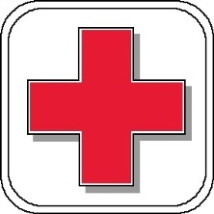
- One electric scooter
- Electric wheel chairs
- Wheel chairs
- Several walkers

You may contact our chapter commander for additional information concerning the above listed items.

NOT YET A MEMBER OF DAV?
We are dedicated to a single purpose: empowering veterans to lead high-quality lives with respect and dignity. Join the over 1.3 million men and women in our ranks and have your voice heard.
To learn more about the DAV mission and how you can get assistance and/or volunteer and support the DAV, visit the membership page on www.dav.org.

Secretary Wilkie Thanks President Trump for Making “988” America’s New National Suicide Prevention Number

Department of Veterans Affairs Secretary Robert Wilkie released the following statement after President Trump signed the National Suicide Hotline Designation Act:
“People in distress and in need of timely care should face the fewest obstacles possible to get help. The bill President Trump signed today will soon make it easier for those at risk to be quickly connected to a trained responder and will help save lives.”
Currently, anyone in need of timely crisis suicide prevention resources can reach the National Suicide Prevention Hotline by dialing 1-800-273-8255. Veterans who call that number can press 1 to be connected to the Veterans Crisis Line.
During the transition to 988, Americans who need help should continue to contact the National Suicide Prevention Lifeline by calling 1-800-273-8255 (1-800-273-TALK) and through online chats. Veterans and service members may reach the Veterans Crisis Line by pressing 1 after dialing, chatting online at www.veteranscrisisline.net, or texting 838255.
(Department of Veterans Affairs)

Fees at national parks waived for veterans, Gold Star families starting next month
526
The U.S. Air Force Air Demonstration Squadron "Thunderbirds" fly over Yosemite National Park on Oct. 1, 2018. Starting next month, all veterans and Gold Star families will be granted free admission to national parks like Yosemite. (Staff Sgt. Ashley Corkins/Air Force)
Starting next month, veterans and Gold Star families will be able to visit national parks and other public lands for free, under a new initiative from the Department of the Interior announced on Wednesday.
Active-duty service members and their families are already granted free access to those sites under existing department rules. The new announcement broadens that benefit to more than 20 million more individuals in recognition of their service and sacrifice on behalf of the country.
In a statement, Interior Secretary David Bernhardt said the move gives all veterans “free access to the iconic and treasured lands they fought to protect.” The policy goes into effect starting on Veterans Day, Nov. 11.

Vets with disability ratings can get lifetime access to over 400 national parks for free — here’s how
Bernhardt and other federal officials made the announcement during a ceremony at the Iowa Gold Star Museum, which focuses on the history of the state’s veterans and their families.
“Our veterans and Gold Star Families have made incredible sacrifices to defend our freedoms and our homeland,” Sen. Chuck Grassley, R-Iowa, said in a statement. “Ensuring that they are able to enjoy all of the natural wonders of the country that they’ve served is one small way of saying thank you.”
The policy includes admittance to well-known sites like Yellowstone National Park in Wyoming, Mount Rushmore in South Dakota, Grand Canyon National Park in Arizona and Shenandoah National Park in Virginia.
Interior officials did not provide cost estimates for the move, but said that the policy change will affect about 2,000 public locations across the country. Fees for the sites can range from a few dollars per person to nearly $100 for some weekly and annual passes.

House OKs free national park access for Gold Star families
The U.S. House of Representatives has passed a proposal from two Maine lawmakers to give families of fallen military service members free access to national parks.
The Associated Press
For free access to the sites, veterans will have to present a Department of Defense Identification Card, a Veteran Health Identification Card, a government-issued Veteran ID Card or a state-issued U.S. driver’s license or identification card confirming an individual’s status as a veteran.
Gold Star family members can use similar Defense Department identification cards to verify their status.
National parks officials already run promotions throughout the year to offer free admission to all visitors on certain holidays, including Veterans Day.
While most national parks sites have remained open or re-opened in recent months amid the ongoing coronavirus pandemic, some programs and facilities still have limited access. Parks officials encourage all visitors to check with local parks administrators before traveling to the sites to ensure safe visits.
Bernhardt also announced Wednesday plans to waives entrance fees to national parks, wildlife refuges and other public lands for all 5th grade students and their families from now until Aug. 31, 2021. The move was made because many families may not have been able to take advantage of the department’s Every Kid Outdoors Annual 4th Grade Pass program because of pandemic precautions earlier this year.
More information on the fee waivers will be posted on the department’s website.

( Leo Shane III, Military Times)

SEEKING EMPLOYMENT?

    - Capital One, PepsiCo, and many other veteran-centric companies are hiring. See the list at www.military.com
    - Bank of America, CVS, Bankers Life, Paragon Systems and Wal-Mart are hiring veterans.
    - State of Florida has numerous positions available. See their Vacancy Search page for details.
    - DAV hosts All Veterans Career Fairs nationally
    - Try the Lee County Human Services Information Network (HSIN)
    - Check out www.FLJobNetwork.com
    - Goodwill Industries
    - www.vacasa.com/careers/positions/ - Current job openings statewide

Volunteer Opportunities:

Lee County Volunteers:
Emergency Management Volunteers – Contact Jonathan Diamond jdiamond@leegov.com 533-0615
Medical Reserve Corps (MRC) - 461-6109 or South West Florida Medical Reserve Corps website.
Lee County Sheriff’s V.O.I.C.E. - 477-1422 or Lee County Sheriff’s VOICE website.

If you are aware of other volunteer opportunities in the area, please notify the Commander.

Honor Flight Network – Since May 2005, Honor Flight has been honoring veterans of WW-II, with free flights to and a tour of Washington, DC. To learn more or to donate, contact them. The Collier Count Hub serves Southwest Florida. Future plans include providing flights for veterans of Korea and Vietnam.

On the VA Public Affairs web page, you can subscribe to receive email updates, download News Releases, speeches, etc., and learn about their major programs: Intergovernmental Affairs, Adaptive Sports Programs, the Homeless Veterans Initiative and more.

Vietnam Ships List Update – See the updated list here.

VA Watchdog: https://www.vawatchdog.org/tdiu-unemployability.html

When you renew your Florida driver’s license, remember to check-off for donation to DAV. Each one generates $1.00 for DAV Florida. The proceeds fund the Service Program and averages $55K/year.

DAV Websites:
To view current and past issues of DAV Magazine, click here.
To view various DAV National reports and bulletins, click here.
To view Current DAV National News, click here.
DAV Department of Florida Current Newsletter and more is available here.

Branch of Service News Links:
http://www.af.mil/News.aspx
http://www.navy.mil/listStories.asp?x=4
http://www.marines.mil/News.aspx
http://www.army.mil/news/
http://www.uscgnews.com/go/doc/4007/2156594/
http://www.defense.gov/news/articles.aspx

Other Local (Cape Coral) Military and related Community Organizations:

Submarine Veterans Barb Base meets the 1st Tuesday each month at 7:00 P.M. at the Big Ten Tavern, 4703 SW, 16th PL. Cape Coral, FL 33914
Navy Seabees: Please contact Commander David Dague at 239-560-6128 for more information.
Marine Corps League – Meets 2nd Mondays at 7:30 P.M. at the Southwest Florida Military Museum, 4820 Leonard Street. Marines, Fleet Marines and any honorable discharged veteran is welcome. Membership $35/annually. 239-549-1853.
Fleet Reserve Association – Meets 2nd Thursdays at 11:30 with Lunch following meeting. Former and active duty Navy, Coast Guard and Marines are welcome. We meet now at the Perkins Restaurant, 1502 Cape Coral Parkway, Cape Coral, Fl. Contact Ralph Camp 239-257-5848 for more info.

Vietnam Veterans of America (VVA) #594 – Meets 3rd Mondays at 7:00 P.M. at VFW Post 8463, 4709 SE 11th Place. All veterans welcome. 239-220-2369.

Destroyer – Escort Sailors Association Southwest Florida – meets every third Thursday at the Military Museum in Cape Coral, FL. Call Werner Grabner for more information at 239-458-8471

Patriot Guard Riders is, according to their “about us” page, “a diverse amalgamation of riders from across the nation. We have one thing in common besides motorcycles. We have an unwavering respect for those who risk their very lives for America’s freedom and security including Fallen Military Heroes, First Responders and Honorably Discharged Veterans.” In addition to the website, more info is available from Cheryl Haines, Dixie Region Captain, Dixie@PatriotGuard.org.

Interested in your business or organization being advertised in this newsletter?
Our circulation reaches over 800 members of our Chapter of disabled veterans and their families. In addition, numerous copies are distributed at drop points around the community. Contact the Chapter Commander for additional information.
Business card size ads: $100 annually
PLEASE, PATRONIZE OUR SPONSORS AND LET THEM KNOW YOU SAW THEIR AD IN THIS NEWSLETTER!
