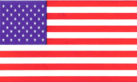
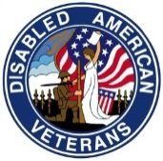
DisabledAmericanVeterans
Gerard P. Walsh, Chapter 16 Commander 908.756.6220
232 Union Ave (RT28) Somerville, New Jersey 08876

Dear Editor,

As Commander of the Disabled American Veterans Chapter 16 of Somerville, its officers and volunteers, I would like to say thank you to the citizens of Warren and its surrounding communities for their wonderful generosity during our Father’s Day weekend Forget-Me-Not capital funding drive. One hundred percent of the contributions received will go directly to veteran patients at the VA Lyons and East Orange facilities.

In addition, we would like to thank all of the merchants in Warren center who provided our volunteers with a venue for our presence; namely, the Country Squire Restaurant, Kings Supermarket, Dunkin Donuts, Bagels 4 U, A&P Supermarket and Warrenville Hardware.
Once again, we appreciate all your kindness and generosity.

The DAV is a veterans organization that helps veterans and veterans in the VA hospitals and VA nursing homes. We like to say “Building Better Lives for America’s Disabled Veterans”. Our chapter has over 700 members from WWII, Korean War, Vietnam, Persian Gulf War, Iraq (Post-Gulf War), Afghanistan War and Iraq War. DAV Chapter 16 meets every month on the fourth Saturday at 10:00 a.m. There is no meeting in July. We meet at the American Legion Post 12, located at 232 Union Ave. (RT28) in Somerville, NJ 08876.

Regards,

Gerard P. Walsh
Commander
DAV Chapter 16

