DISABLED AMERICAN VETERANS
Chapter 17 Doylestown P.O Box 2173 Doylestown. Pa 18901
Motto: “If I cannot speak well of our comrades. I will not speak ill of them”
Next Meeting
When: JULY 27TH 2020 NO MEETING
Where:

DAV’S Mission Statement: Fulfilling our promises to the men and women who served.
We are dedicated to a single purpose: empowering veterans to lead high-quality lives with respect and dignity. We accomplish this by ensuring that veterans and their families can access the full range of benefits available to them; fighting for the interests of America’s injured heroes on Capitol Hill; and educating the public about the great sacrifices and needs of veterans transitioning back to civilian life.
- Providing free, professional assistance to veterans and their families in obtaining benefits and services earned through military service and provided by the Department of Veterans Affairs (VA) and other agencies of government.
- Providing outreach concerning its program services to the American people generally, and to disabled veterans and their families specifically.
- Representing the interests of disabled veterans, their families, their widowed spouses and their orphans before Congress, the White House and the Judicial Branch, as well as state and local government.
- Extending DAV’s mission of hope into the communities where these veterans and their families live through a network of state-level Departments and local Chapters.
- Providing a structure through which disabled veterans can express their compassion for their fellow veterans through a variety of volunteer programs.
Announcements
- ALL FUNDRASIERS HAVE BEEN PUT ON HOLD DUE TO THE PANDEMIC
- STATE AND NATIONAL CONVENTIONS HAVE BEEN CANCELLED
- The Bucks county YMCA is looking to reopen July 1st 2020. Follow www.ymcabucks.org for more information.

Commanders Remarks:
Thank you for your support. Stay Safe. God Bless
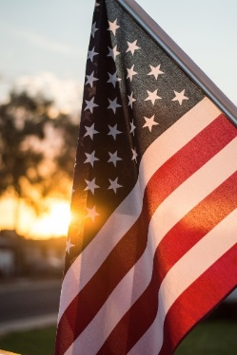

George H Lindsey Jr. - Commander
Kim Carter- Guerin - Senior Vice
Jack Thomas- Junior Vice
Bob Staranowicz- Adjutant
Lou Rizzo- Treasurer
Jack Thomas- Service Officer
Ron Harkins- Chaplain
Don Parzanese- Sergeant of Arms
Bill Severns- Membership
Fred Ewald- Trustee
Thomas Herron- Trustee
Glenn Schumacher - Trustee

