
DISABLED AMERICAN VETERANS
Chapter 13
Post Office Box 639
Glen Burnie, MD 21061

___________________________________________________________________________________
Commander/Editor Aux. Commander Adjutant
Pete Schwarz Pat Schwarz Thomas Sadler
(410) 551-6760 (410) 410-760-3577
____________________________________________________________________________________________________
Chapter meetings every 1st Thursday of the month at 7:00PM, 8068 Quarterfield Road, Severn, Maryland
May 2010 – August 2010

Dear Comrades:
We had a great time at the installation banquet and ceremony installing our chapter and auxiliary unit officers. As always, we enjoyed the company of our fellow comrades from the Department of Maryland, from Chapter 21 and other chapters. We also had the pleasure of having most of the DAV van drivers with us who spent many hours on the road to transport needy veterans to the Glen Burnie VA Clinic. I salute all drivers and Thommie Hawkins for their dedicated service to our veterans. I am honored for having been selected again as the chapter commander for 2010/2011. I will do my best to carry out the duties of the commander. I will have the opportunity again this year to participate in the Annual Department Convention at the end of May in Ocean City. I pray that our Treasurer, Billie Miles, will be able to attend the convention as well after recuperating from his heart by-pass operation.

As we are enjoying warmer weather again, I hope to see more members at our monthly chapter meetings and other activities this year. We will participate in the Glen Burnie Memorial Day Parade on May 23 and we will need volunteers to march with us. Our chapter picnic is scheduled to be on August 15 at Fort Smallwood Park. We have an ongoing need for van drivers at the Glen Burnie VA Clinic. Please contact one of the volunteers at the transportation office of the Glen Burnie VA Clinic for information on how to become a volunteer driver. Transporting needy veterans to the clinic is very fulfilling and rewarding volunteer work. You can choose your hours and days you prefer to drive. In the fall we will ask you to help again with our annual fund raising efforts. Our Forget-Me-Not Fund Drive will be on Saturdays and some Sundays in September again in front of the Lauer’s Food Market and Walmart. Please mark your calendar and offer your time.

For God, Country and the DAV

- Pete
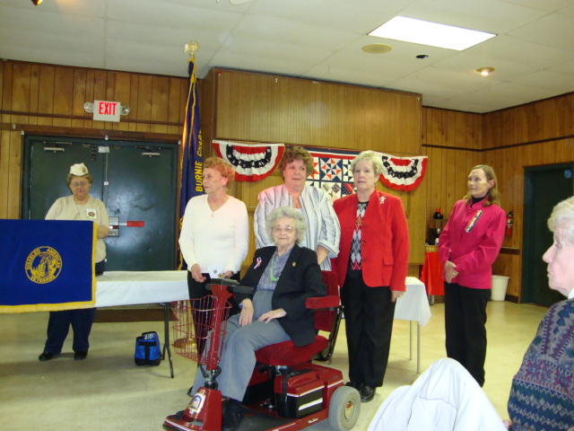
Events
May 6, 2010 General Meeting, 7:00pm
May 23, 2010 Glen Burnie Memorial Day
Parade
May 27, 2010 Executive Meeting, 7:00pm
May 31, 2010 Memorial Day (Crownsville)
Jun. 2-5, 2010 State Convention at
Ocean City (no chapter meeting)
Jun. 24, 2010 Executive Meeting, 7:00pm
Jul. 1, 2010 General Meeting, 7:00pm
Jul. 4, 2010 Independence Day, fly your colors
Jul. 22, 2010 Executive Meeting, 7:00pm
Aug. 5, 2010 General Meeting 7:00pm
Aug. 15, 2010 Chapter picnic at Fort Smallwood
Park
Aug. 26, 2010 Executive Meeting 7:00pm

(Ruth Wilcoxen, Shirley McCloskey, Janice Null, Pat Schwarz, Carol Simmons, Annalee Mullenax)
2008/2009 Chapter Officers Unit Officers
Commander Pete Schwarz Pat Schwarz
Sr. Vice Commander Bob Mullenax Janice Null
Jr. Vice Commander Leo Sparks Annalee Mullenax
Treasurer Billie Miles Rick Barnes
Chaplain/Historian Johnny Hall Ida Adams
Sergeant of Arms Ron Adams
Officer of the Day Carl Bonner
Judge Advocate Frank McMonegal
Adjutant Thomas Sadler Shirley McCloskey

DAVA Unit Commander’s Message:

Hello,
I have to tell you… I am so excited about this coming year. We have a new slate of officers. We are so glad to have Janice Null as Sr.Vice Commander and Shirley McCloskey (former Commander of Unit #13) as our new Adjutant. Not only are we looking forward to the fun and fellowship of each other, but the opportunity to serve our veterans who have so valiantly given themselves for the freedoms that we enjoy today. We need your help. We need your good ideas on what we can do for our veterans. I look forward to serving with you as we brain storm together. Barbara Swann, from Lock Raven has requested twin size patriotic quilts, afghans, either knit or crocheted, for those in the Hospice Unit.

Don’t forget Memorial Day Parade is May 23rd. We would like to have DAVA members ride in one of the Vans. Also it would be wonderful if we could make a good showing at Crownsville Veterans Cemetery for the memorial service they have. These services are always nice. Hope to see you at the regular meeting held the 1st Thursday of each Month at the American Legion Post on Quarterfield Rd. at 7:00 pm.

United We Stand,
Pat Schwarz, DAVA Unit Commander

It’s baseball time!
The Department of Maryland will again be participating in several “DAV Night at the Ball Park”: May 23, 2:05pm – Bowie Baysox vs. New Hampshire Fisher Cats (tickets are $7); June 6, 2:05 pm – Southern Maryland Blue Crabs vs. York Revolution, Regency Furniture Stadium, Waldorf, MD (tickets are $10); July 22, 7:05pm – Aberdeen Ironbirds vs. Tri-City Valley Cats Ripken Stadium, Aberdeen, MD (tickets are $10 and include a free cap); July 23, 7pm – Frederick Keys vs. Myrtle Beach, Harry Grove Stadium, Frederick, MD (tickets are $4 and there will be fireworks after the game!); July 24th, 4:10pm – Baltimore Orioles vs. Minnesota Twins, Camden Yards, Baltimore, MD (tickets are $6 for lower reserve seats)
Baseball is a great way to get out and enjoy time with fellow veterans. Tickets can be purchased as part of the chapter service program. The chapter will have a limited amount of free tickets for needy veterans. Contact the department at 410-539-1310 to purchase tickets for any of the above games.

Service Officer Report:

National Health Reform and You
In as clear an indication of that as anyone could ask for, the House unanimously passed separate legislation explicitly citing TRICARE as “qualifying health coverage” for purposes of the new law. The Senate is working now to pass the same legislation. VA care and TRICARE For Life already were explicitly designated in law. That means eligible beneficiaries of those programs won’t be subject to financial penalties that can be imposed on people who don’t have qualifying insurance.
That said, let’s be clear on another key issue. Can anyone guarantee that there will never be any unfavorable changes to military and VA programs? No. Do we know for sure how all the details will play out? No. There’s always a potential for unintended consequences, and there’s always the potential for new initiatives to arise (see below). But if you were worried that national health reform legislation is somehow aimed at whacking military beneficiaries’ health coverage, that’s just not so. Frankly, we think the much more significant issue for Medicare – and for the military community and the rest of America -- is what proposed changes will be recommended by the new National Commission on Fiscal Responsibility and Reform that’s supposed to report by Dec. 1 on options to reduce the national debt.
(MOAA, March 25, 2010)
Agent Orange
Well over 100,000 Veterans exposed to herbicides while serving in Vietnam and other areas will have an easier path to qualify for disability pay under a proposed regulation published by the Department of Veterans Affairs (VA) that adds three new illnesses to the list of health problems found to be related to Agent Orange and other herbicide exposures. “This is an important step forward for Vietnam Veterans suffering from these three illnesses,” said Secretary of Veterans Affairs Eric K. Shinseki. “These warriors deserve medical care and compensation for health problems they have incurred.” The regulation follows Shinseki’s October 2009 decision to add the three illnesses to the current list of diseases for which service connection for Vietnam Veterans is presumed. The illnesses are B cell leukemias, such as hairy cell leukemia; Parkinson’s disease; and ischemic heart disease. The Secretary’s decision is based on the latest evidence of an association with widely used herbicides such as Agent Orange during the Vietnam War, as determined in an independent study by the Institute of Medicine (IOM). Even though this is a proposed rule, VA encourages Vietnam Veterans with these three diseases to submit their applications for compensation now so the Agency can begin development of their claims and so they can receive benefits from the date of their applications once the rule becomes final.
(Department of Veterans Affairs)
A combat soldier’s story:

Rick Barnes and Jan Holland were in Phoenix because Rick was attending his commencement graduating with a Ph.D. from Capella University. Congratulations! They had the opportunity to talk to Major Tammy Duckworth, the commencement speaker and a veteran of the war in Iraq. Major Duckworth currently serves as the Assistant Secretary of Public and Intergovernmental Affairs for the United States Department of Veterans Affairs.

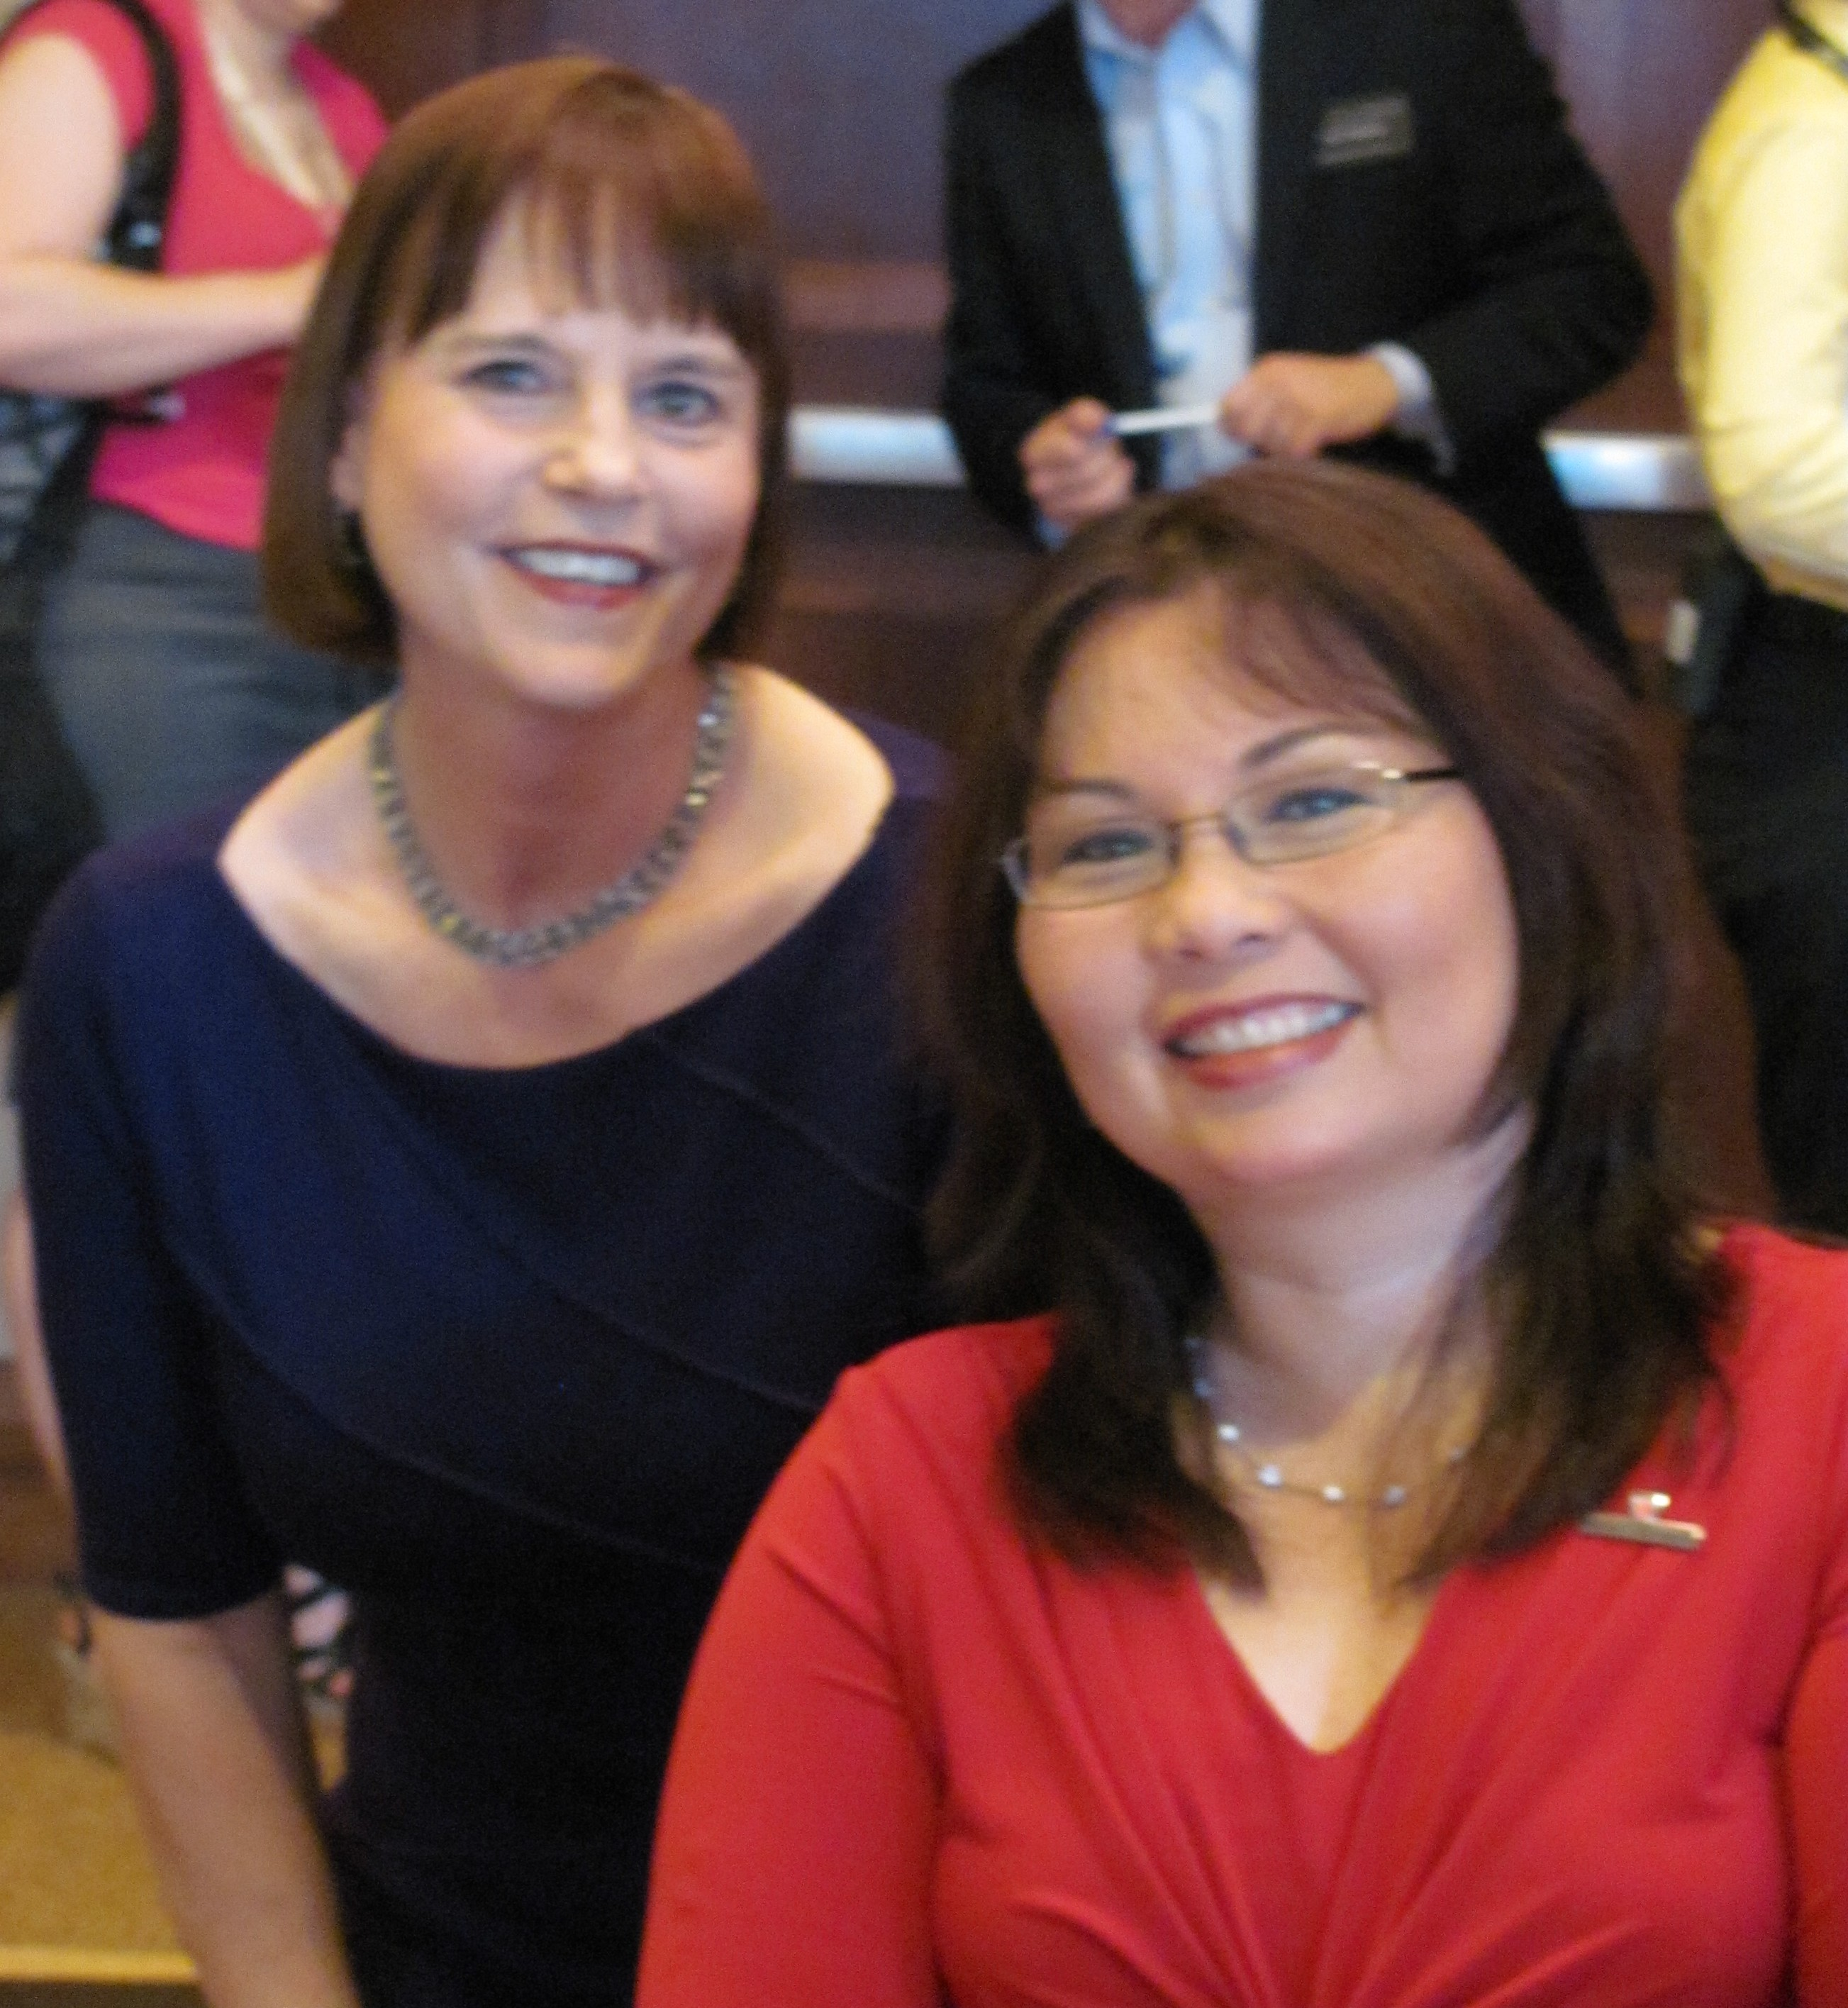
Her military service is listed in part as follows: Following in the footsteps of her father whose long military career spanned service from World War II to the Vietnam War, as well as her father's ancestors who fought in every major American conflict since the Revolutionary War, Duckworth joined the Army Reserve Officers' Training Corps (Army ROTC) as a graduate student at George Washington University in 1990. She became a commissioned officer in the United States Army Reserve in 1992 and chose to fly helicopters because it was one of the few combat jobs open to women. As a member of the Army Reserve, she went to flight school and joined the Illinois Army National Guard in 1996.

Major Duckworth lost the lower part of both legs from injuries sustained on November 12, 2004, when the UH-60 Black Hawk helicopter she was co-piloting was hit by a rocket propelled grenade fired by Iraqi insurgents. The explosion "almost completely destroyed her right arm, breaking it in three places and tearing tissue from the back side of it." Consequently, she was fitted for prosthetics and is now fully mobile. Duckworth received a Purple Heart on December 3, 2004 and was promoted to Major on December 21, 2004 at the Walter Reed Army Medical Center, where she was presented with an Air Medal and Army Commendation Medal. She also has helped establish the Intrepid Foundation and is involved in its fundraising to build a rehabilitation center for other injured veterans.
Jan Holland and Major Tammy Duckworth


DAV Chapter 13 has its own website! You can find it at www.dav.org or www.davmembersportal.org/chapters/md/13 POC: Pete Schwarz (webmaster)

Help us in our fund-raising effort with your donation!
DAV CHAPTER 13, GLEN BURNIE, MD

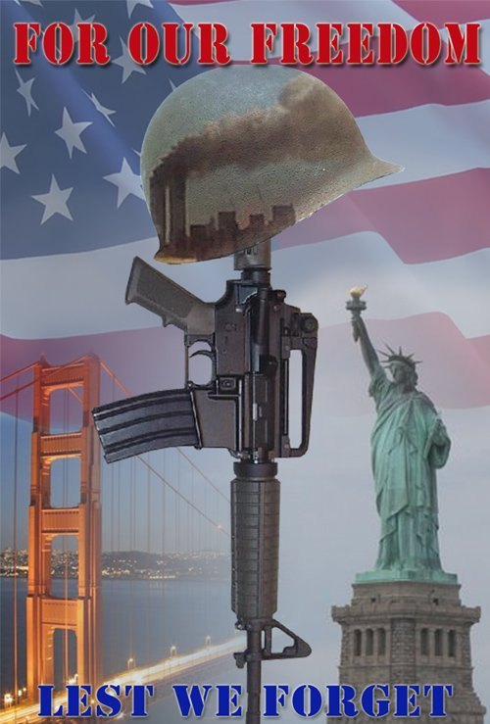
BUILDING BETTER LIVES FOR AMERICA’S DISABLED VETERANS

Freedom is not free!

Please become active in your local chapter of the Disabled American Veterans and tell others about it.

