

VA Southern Nevada Healthcare System (VASNHS)
5th Annual Welcome Home Event

On Monday June 6, 2011 the 5th Annual Welcome Home Event took place at the Palace Station Hotel and Casino located in Las Vegas. This event was co-sponsored by the Catholic War Veterans (CWV) and Auxiliary, the Elks of Southern Nevada Veteran Services, and the Disabled American Veterans Chapters 12, 13, and 15.

Master of Ceremony for this event, NBC (KSNV channel 3) news anchor and air force veteran Dan Ball. This is Dan’s third year participating in this event.

The day began with a special recognition of Normandy and other World War II veterans with the oldest being 95 years old. The Nevada Opera Theatre sang America the Beautiful. The Presentation of colors consisted of four groups; Catholic War Veterans Color Guard, Marine Corps League Color Guard, Nellis AFB Honor Guard, and the Nevada National Guard’s Honor Guard. Next, the Pledge of Allegiance led by Irving Finver and the National Anthem by the Nevada Opera Theatre.

VASNHS Director John Bright gave opening remarks. A Proclamation from the Governor was presented by Terri Jenison, Director of Community Relations of the governor’s office. This was followed by remarks from Congresswoman Shelley Berkley and Congressman Joe Heck, MD.

A Memorial Presentation recognizing the fallen men and women from World War II to the current conflict and a Special Memorial Presentation honoring the last American World War I Doughboy, Frank Woodruff Buckles. At the age of 16, he witnessed the European theatre of World War I, serving in the United States Army as an ambulance driver. In World War II, he became a Prisoner of War in the Philippines and was imprisoned for 39 months. After his return, Frank settled down in West Virginia where he lived until his death on February 27, 2011, at the age of 110. Echo Taps played by the CWV.

Entertainment throughout the day was provided by the VA Vocal Ambassadors, a choir group. They sang patriotic songs and songs from the Word War II era such as the Boogie Woogie Bugle Boy of Company B and Sentimental Journey.

This Welcome Home Event was recognized as the best yet in quality and numbers. Three hundred fifty eight veterans attended with one hundred fifty vendors participating and approximately 75 VA Ambassadors (volunteers) of which about 20 came from the DAV. The breakdown of veterans served are; 117 from OIF/OEF, 183 Vietnam, 33 Korea, and 25 World War II.
The Welcome Home event ran from 10:00 am to 3:00 pm, however, the planning and initial committee meeting began in November 2010.
The planning committee consisted of the following; Chair, Stacey DePriest of the VA, Co-Chairs Tom Mullalley and Jeff Carson of the DAV, Wayne Leroy of the Elks, and James McCawley of the CWV. Other members of the planning committee included Irving Finver of the Jewish War Veterans, Bob Fain of the Catholic War Veterans and the following VA personnel; David Martinez, Ron Winston, Dr. Roy Kekahuna, John Scott, Katherine Budding, Donna Johnson, Nancy Faye, Kelly Edwards-Barron.

This has been a long and tiring process but it was worthwhile. Many heartfelt thanks to chapters 12, 13, and 15 who supported this event.

Respectfully submitted,
Tom Mullalley,
Jr. Past Dept. Cmdr.//Historian
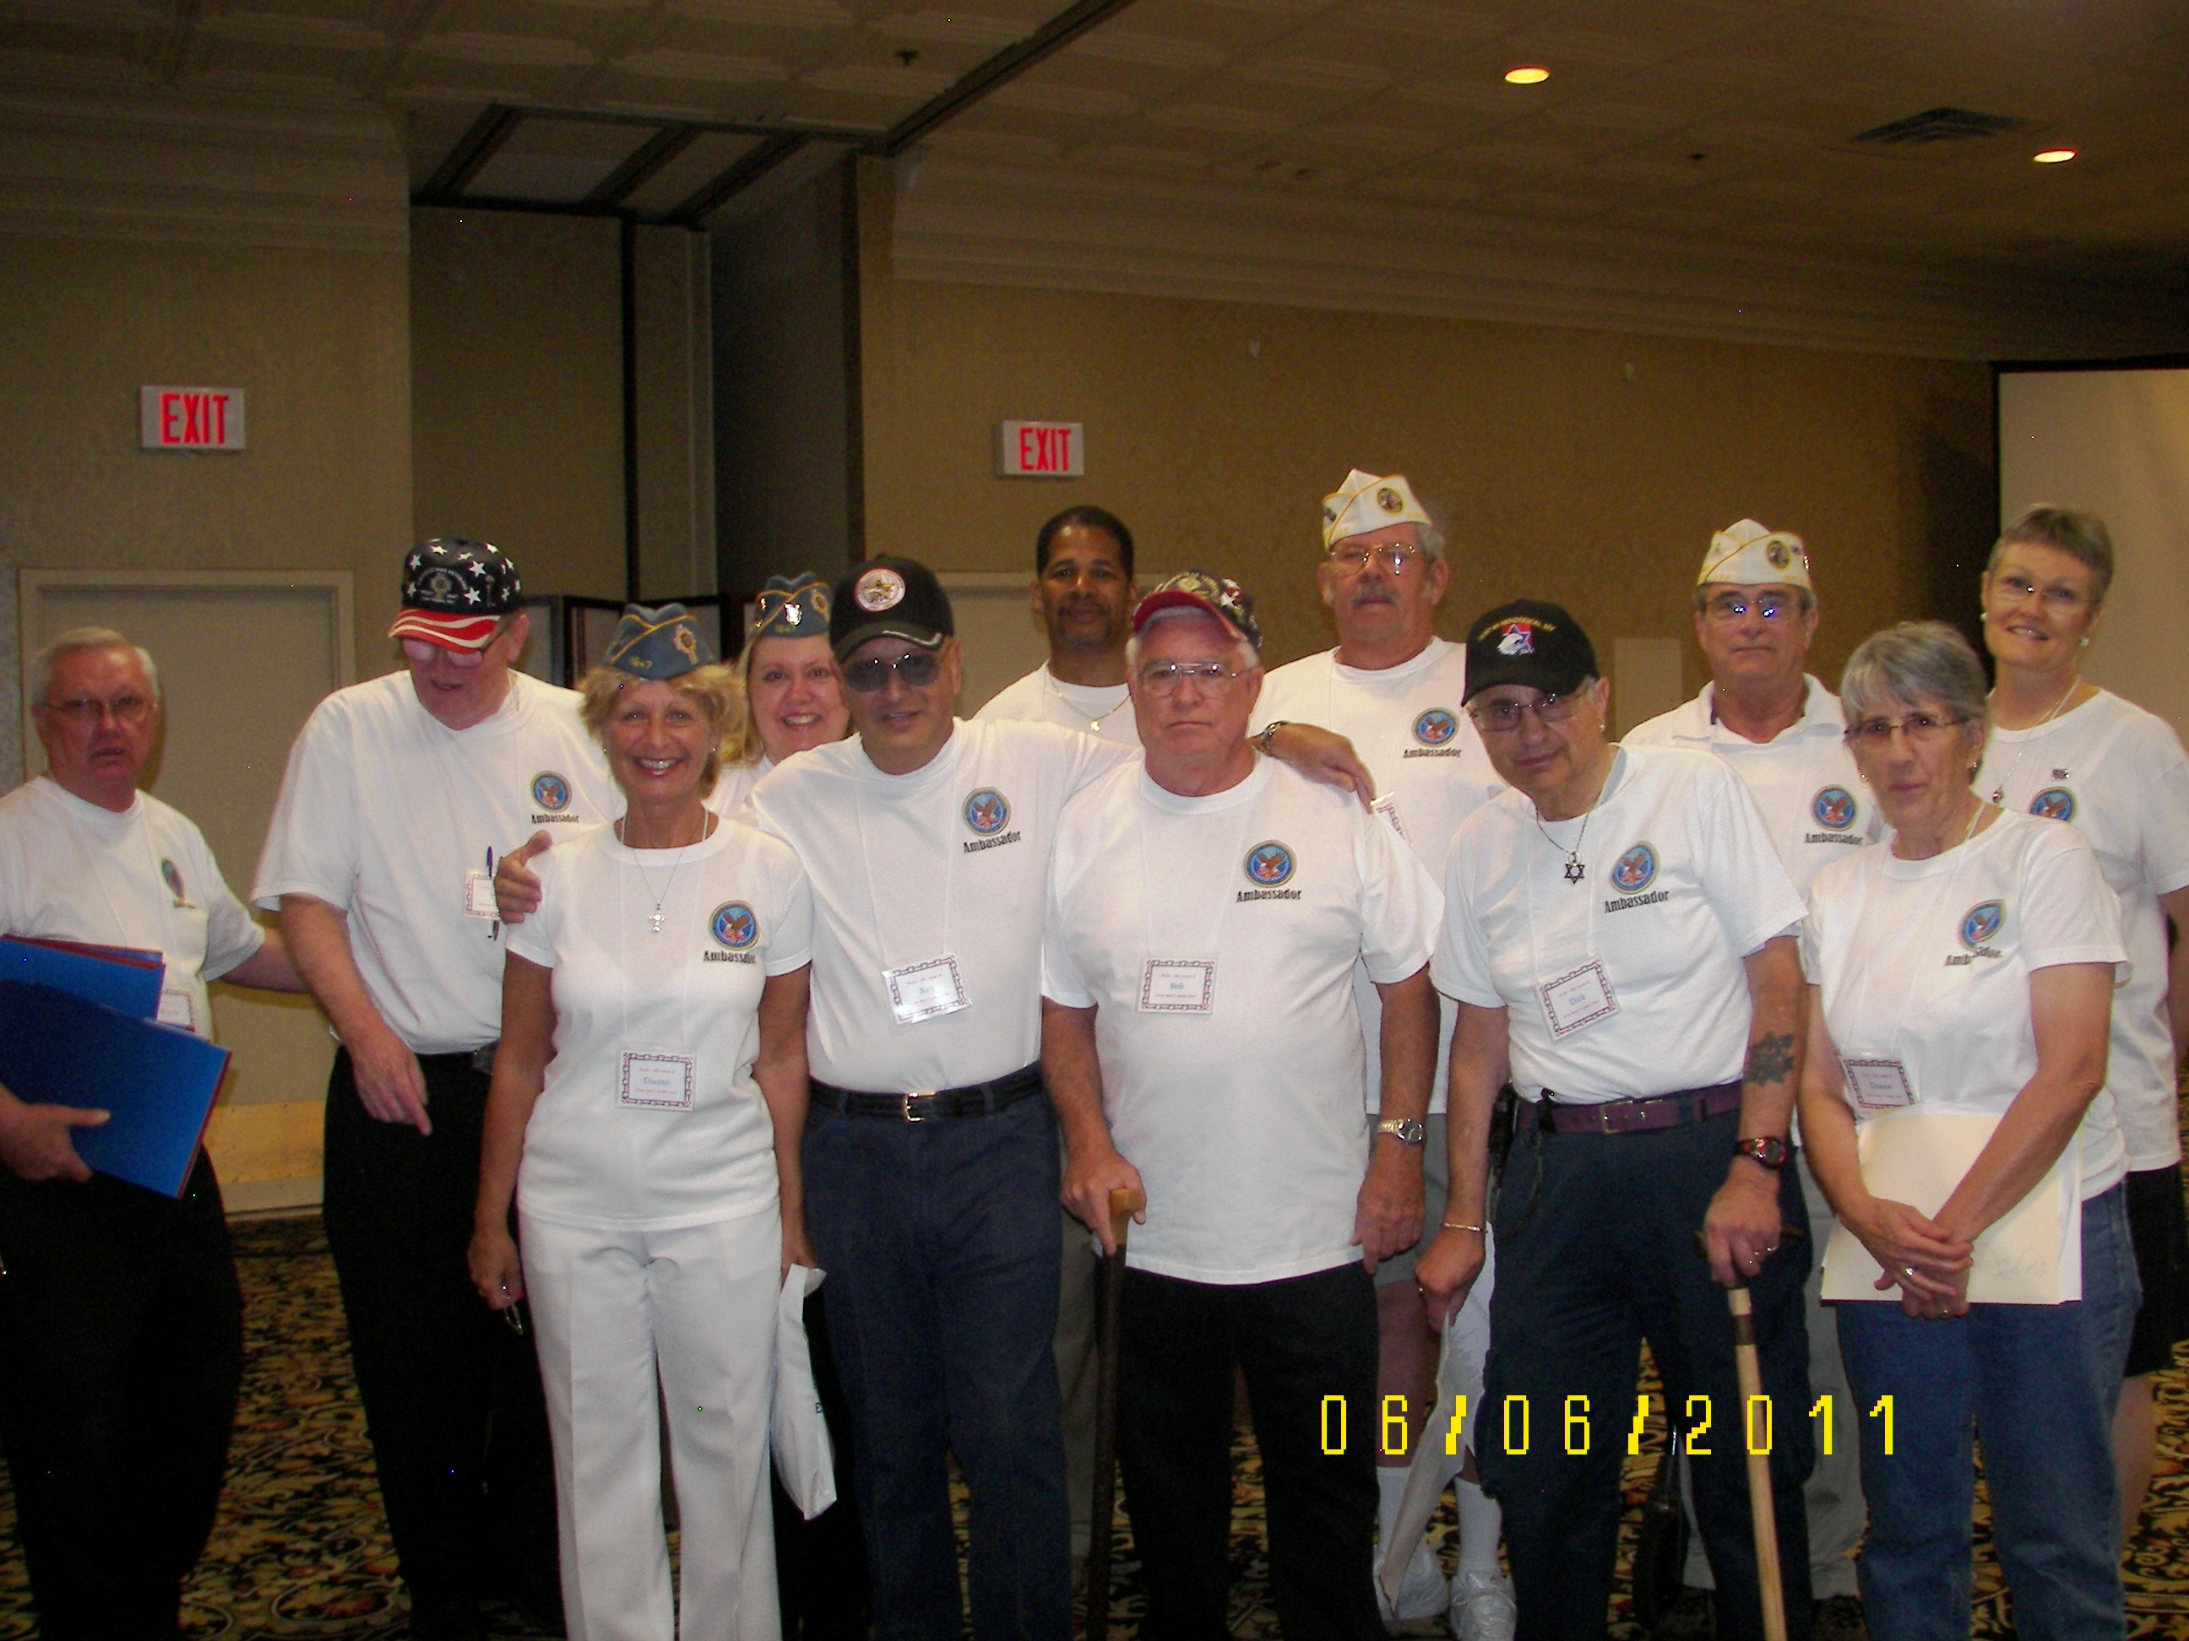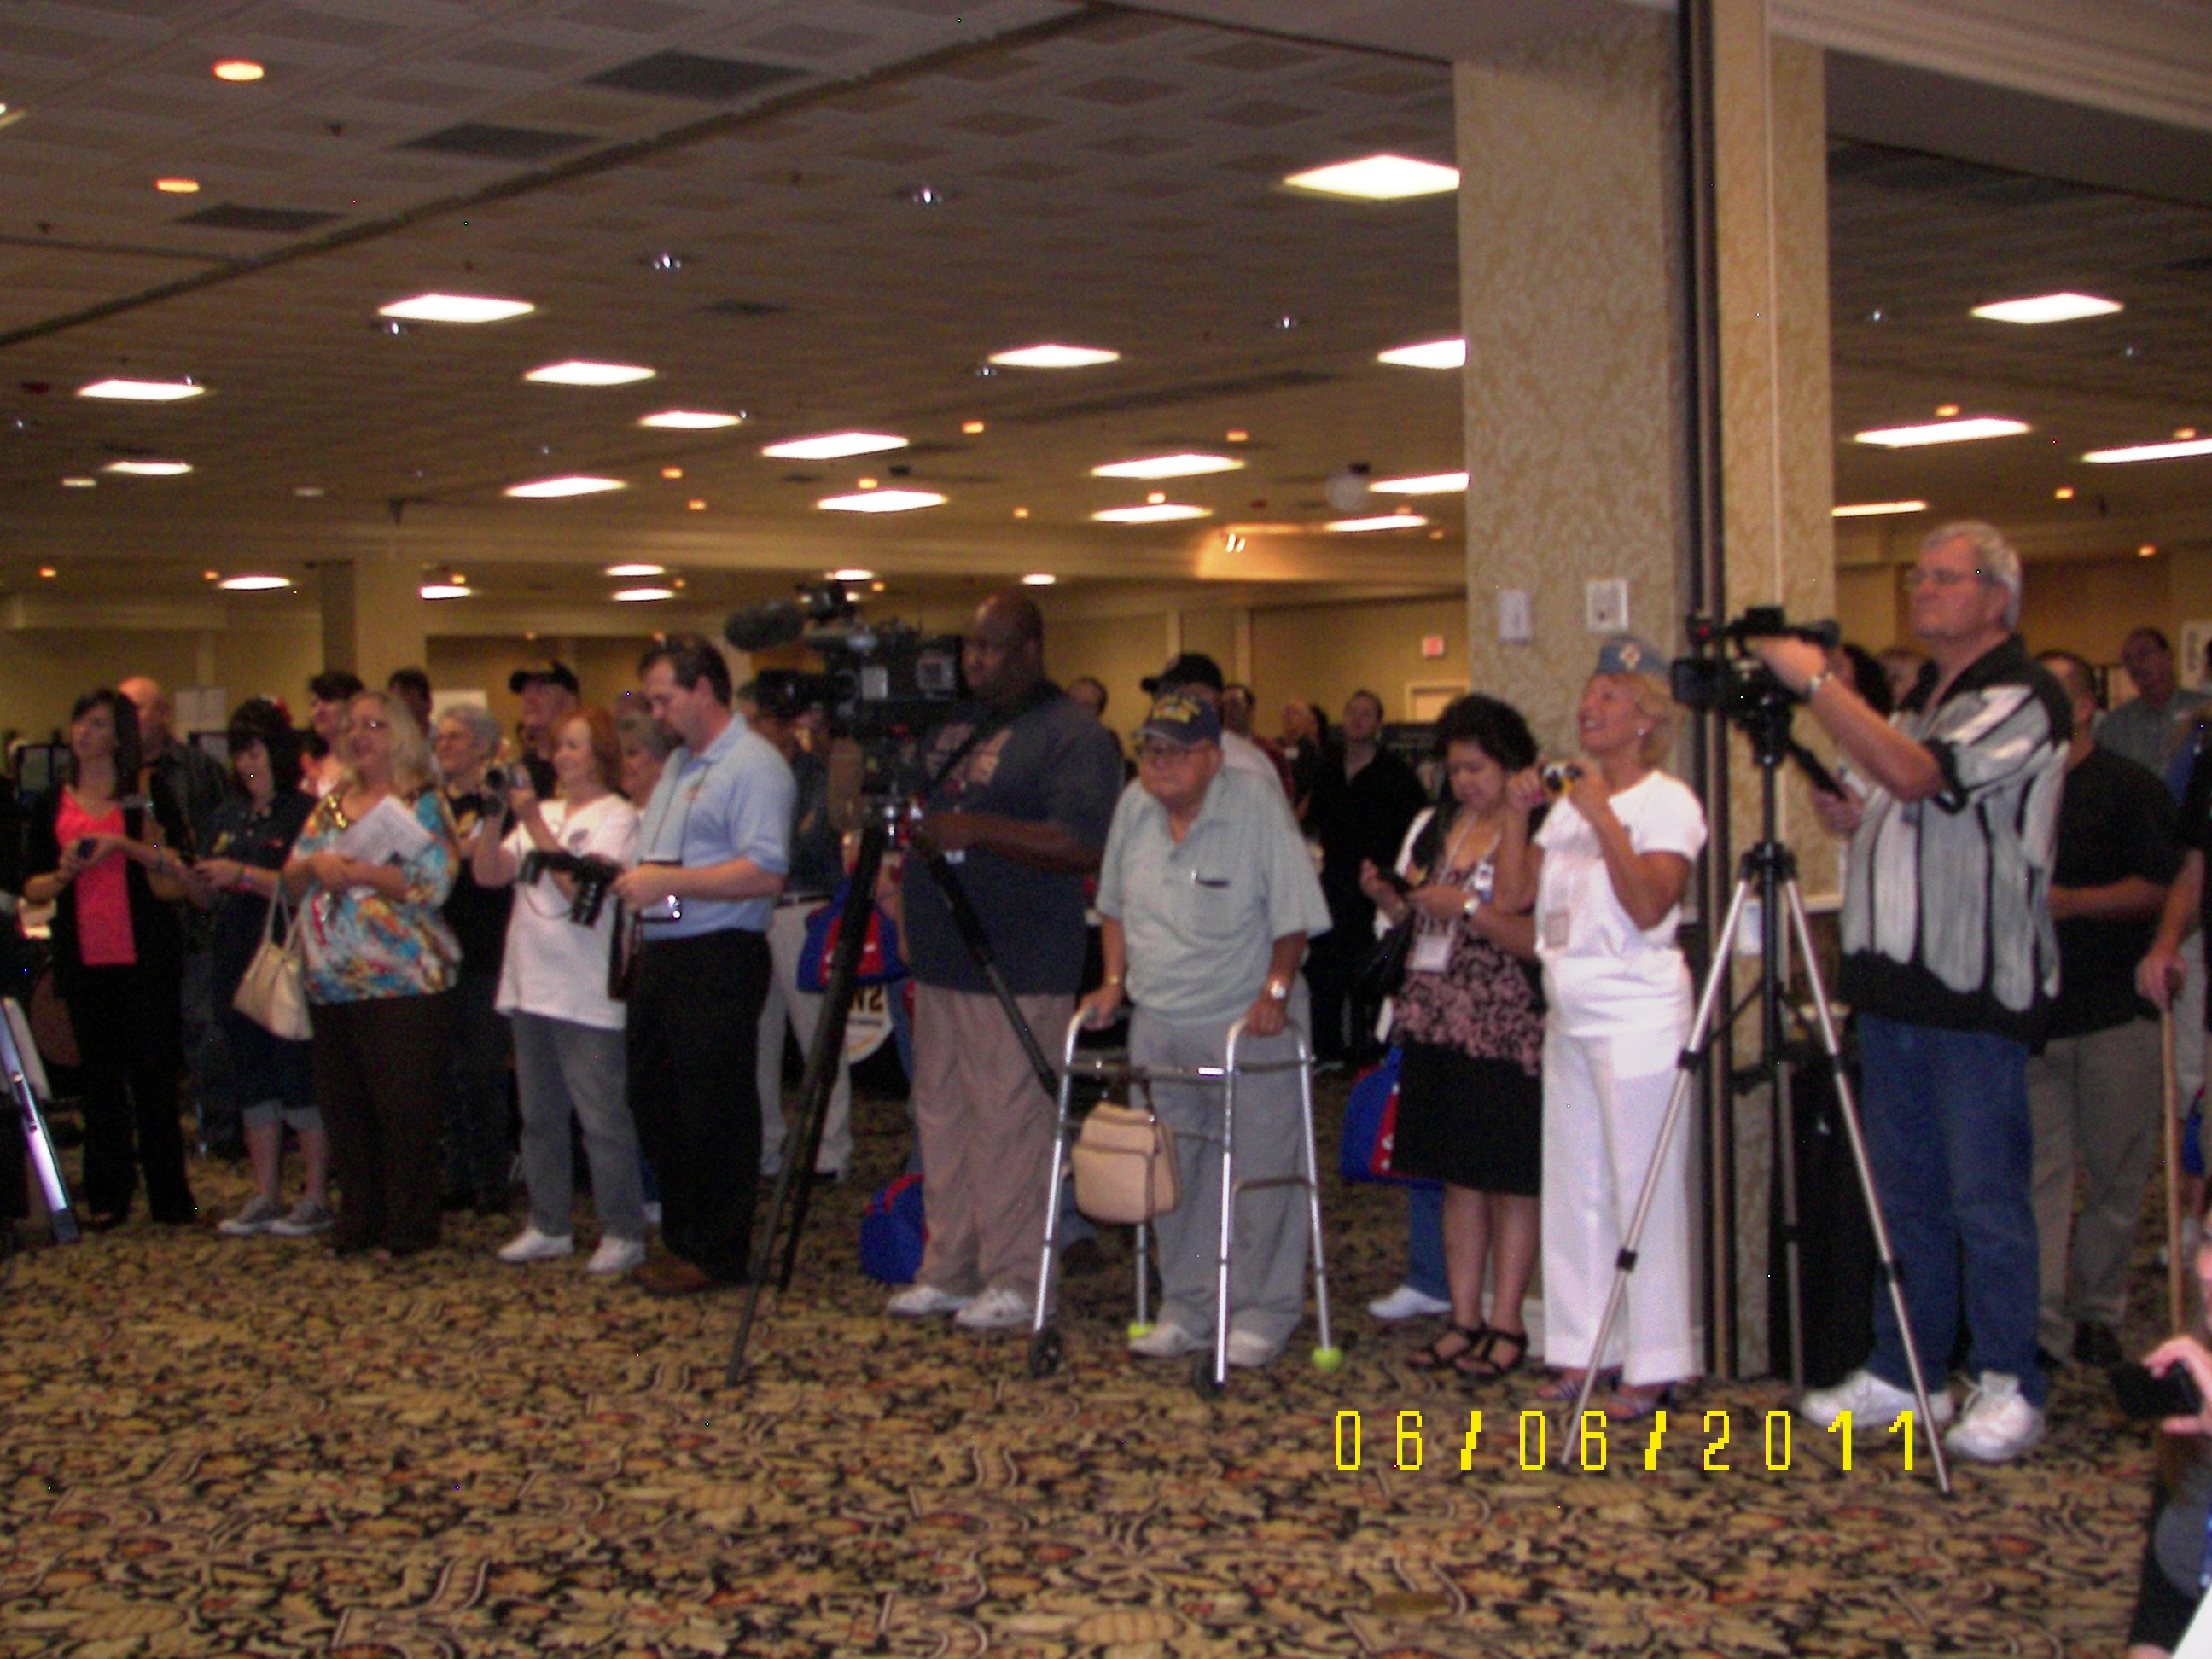
VA Ambassadors Media and attendees, tribute to WW II veterans
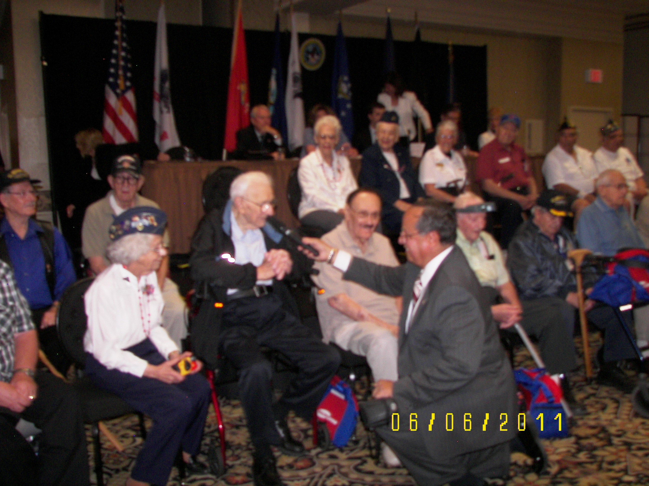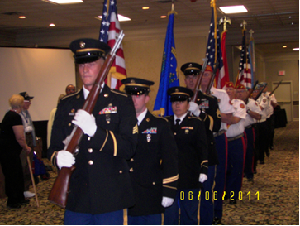
Word War II Veterans Introductions Presentation of Colors

